**UNIVERSITY OF DAR ES SALAAM**



**COLLEGE OF INFORMATION AND COMMUNICATION TECHNOLOGIES (CoICT)**

**DEPARTMENT OF ELECTRONICS AND TELECOMMUNICATION ENGINEERING**

**ES 499: FINAL YEAR PROJECT**

**CONCEPT GENERATION REPORT**

**Project title**: SECURED WIRELESS USB FLASH DRIVE

**Student Name:** KOWERO, WALIDI WAZIRI.

**Reg. No.:** 2020-04-04390.

**Supervisor’s Name:** PROF. BARAKA MAISELI

TABLE OF CONTENTS

CONCEPT GENERATION 1

INTRODUCTION 1

AVAILABLE OPTIONS FOR EACH SUBSYSTEM. 3

Wireless Server (40%) 3

Usb interface (25%) 4

Non-volatile Memory (5%) 5

Power system (5%) 5

Controller (25%) 6

CHOISE OF CONTROLLER: ESP32 VARIABLES 7

ACCESS AND PURCHASING 9

# CONCEPT GENERATION

## INTRODUCTION

This report discusses and optimizes the available options that can be used to achieve the main goal for this project.

This report provides an overview on how the devices and equipment selection to be used to establish the Wi-Fi enabled flash drive as a system.

There are two methods used to perform concept generation for usb wireless flash drive:

1. Concept Table
2. Concept Fan

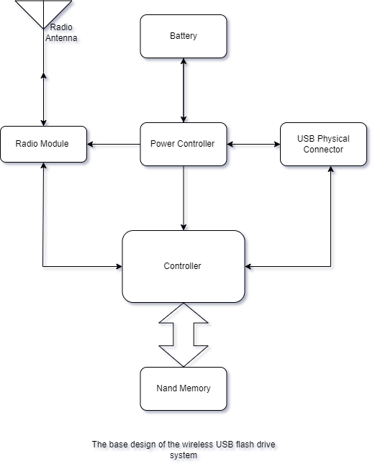From the device block diagram below,

This system is divided into mainly 5 subsystems

1. Usb interface (25%)
2. Wireless server (40%)
3. Controller (20%)
4. Non-volatile memory (10%)
5. Power system (5%)

|  |  |  |
| --- | --- | --- |
| **Part** | **Prerequisite** | **Available raw options** |
| Controller | * More than 3 threads, * Low power management, * Optimized subsystems * More than 20 gpio * High library community | SAMD series,  PIC series,  STM32 series,  Esp32 series, |
| Power System | * Can last more than 24 hours, * rechargeable. | Solar panel, Usb port, Rechargeable battery like lithium-ion, |
| Non-volatile Memory | * Interface: SPI || NAND || eMMC | Micron Nand Memory,  Samsung Nand Memory, eMMC cards, Samsung UFS flash memories. |
| * Storage :> 8GByte |
| Wireless server | * More than 50 Mbytes per second achievable transfer speed * Wi-Fi and Bluetooth connectivity * File transfer Server. | Web Server, Software as middleware, Bluetooth, Wi-Fi  Network Attached Server (NAS). |
| Usb interface | * Usb capability version > 2.0 | Usb type A, B or C |

## AVAILABLE OPTIONS FOR EACH SUBSYSTEM.

Categorization of parts for available options:

1. **Wireless Server (40%)**

This is the combination of hardware and software programing with specific protocol in order to achieve wireless file transfer protocol. According to findings in [1] there several protocols that can be programmed into a controller and be used to provide file transfer service:

* + 1. **Network file sharing (NFS) protocol**: Mostly used in Microsoft computers for file sharing. The fastest of all below protocols.
    2. **Server Message Block (SMB or Samba Server):** used in all major three operating systems that is Windows, MacOS and Linux. Suitable for multiplatform compatibility.
    3. **Internet Small Computer Interface (iSCi protocol):** Old but strong protocol that was used in early development of operating system to transfer and manage files. It is still used in some architectures for file transfer. It is used to manage raw data in disk like backups and virtual machines.
    4. **Apple file protocol**: Used in MacOS devices to perform file transfer to other macOS supported devices with higher performance than SMB protocol.

Concept Table for wireless Server

Likert scale to be used: -

1 - very poor, 2 – Poor,3 - Acceptable,4 – Good,5 - Very good.

|  |  |  |  |  |  |  |  |
| --- | --- | --- | --- | --- | --- | --- | --- |
| Protocol | Flexibility | Multiplatform  Compatibility | Speed | Security | Portability | Robustness | Total |
| NFS | 2 | 1 | 4 | 4 | 1 | 3 | 17 |
| SMB | 4 | 4 | 3 | 4 | 3 | 4 | 22 |
| iSCi | 2 | 5 | 3 | 1 | 5 | 2 | 18 |
| Apple File Protocol | 1 | 1 | 3 | 3 | 2 | 2 | 11 |

Therefore, the protocol with the highest preference is Samba protocol followed by iSCi and NFS

1. **Usb interface (25%)**

This is the interface used by most advanced computerized systems and edge consumer devices. It involves the communication of two or more devices with using differential pair of wires.

There are several usb generations each precedeng the other with higher datarate. Mainly are

* + 1. Usb 1.1 achieving up to 12Mbps
    2. Usb 2.0 achieving up to 500Mbps
    3. Usb 3.0 achieving up to 5Gbps



Concept Table for Usb Interface

Likert Scale used: -

1 - very poor, 2 - Poor, 3 - Acceptable, 4 - Good, 5 - Very good.

|  |  |  |  |  |  |
| --- | --- | --- | --- | --- | --- |
| **Usb generation** | **Speed** | **Cost** | **Compatibility** | **Flexibility** | **Total** |
| 1.1 | 2 | 4 | 3 | 3 | **12** |
| 2.0 | 3 | 4 | 3 | 4 | **13** |
| 3.0 | 4 | 3 | 2 | 4 | **12** |

Therefore, with difference in cost and flexibility usb 2.0 is choosen.

1. **Non-volatile Memory (5%)**

Since this project is adopting the project done in the practical training 3 2022/23 of developing a local consumer based usb flash drive which used a non-volatile Micron Nand memory MT29F64G08 for data storage.

1. **Power system (5%)**

For better performance and affordability, better requirement of power storage and source will be duscussed as the effect of the established system.

Power Rating of the established system will therefore later be used to construct a desired goal which aimed for this device to support for file transfer for more than 24 hours.

1. **Controller (25%)**

Controllers can be categorized using concept fan as follows

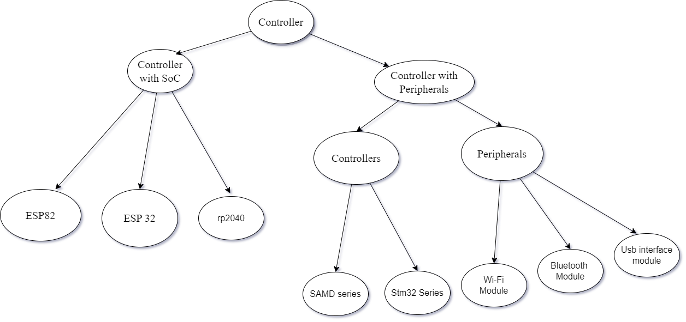

Figure 1 Concept fan for available Controller options

One advantage of controller with system on chip (SoC) architecture over controller with peripheral is that it save power, space, cost and time.

Therefore, Controller with system on chip(SoC) preceedes those with peripherals.

Classification of SoC controller using specification table:

|  |  |  |  |  |  |
| --- | --- | --- | --- | --- | --- |
| **Chip Series** | **Cores** | **Supported Subsystems** | **Clock frequency** | **RAM/ROM** | **General Purpose pin** |
| Esp 82 | 1 32-bit RISC-V CPU | Wi-Fi,SHA-256, AES,SPI,I2C,CAN,Wire,ADC, PWM,UART, ETHERNET | 80MHz | 64 KB/4 MB | 17 |
| Esp 32 | 1,2 32-bit RISC-V CPU | Wi-Fi,SHA-256, AES, SPI, BLE, RTOS, ZigBee, Touch Sensor,ADC,CAN,Wire,PWM,UART, ETHERNET | 80MHz – 240MHz | 520 KB- 16 MB/ 338 KB -16 MB | 34 - 45 |
| Rp2040 | 2 Cortex(M0+) | SHA-256, AES,SPI,I2C,CAN,Wire,ADC, PWM,UART,ETHERNET | 133MHz | 260 KB/2 MB | 30 |

Here, Esp32 preceeds other microcontrollers in term of architecture, storage, amount of supported subsystems and cpu frequency.

## CHOISE OF CONTROLLER: ESP32 VARIABLES

Based on the initial requirement specification of controller for secured wireless Usb flash drive that are:

* + More than 3 threads,
  + Low power management,
  + Optimized subsystems,
  + More than 20 gpio,
  + High library community,

By using esp product selector with link : [https://products.espressif.com/#/product-selector?names=](https://products.espressif.com/%23/product-selector?names=) . It was easy to select appropriate controller module for this project.

Here is a comparison between different versions of esp32

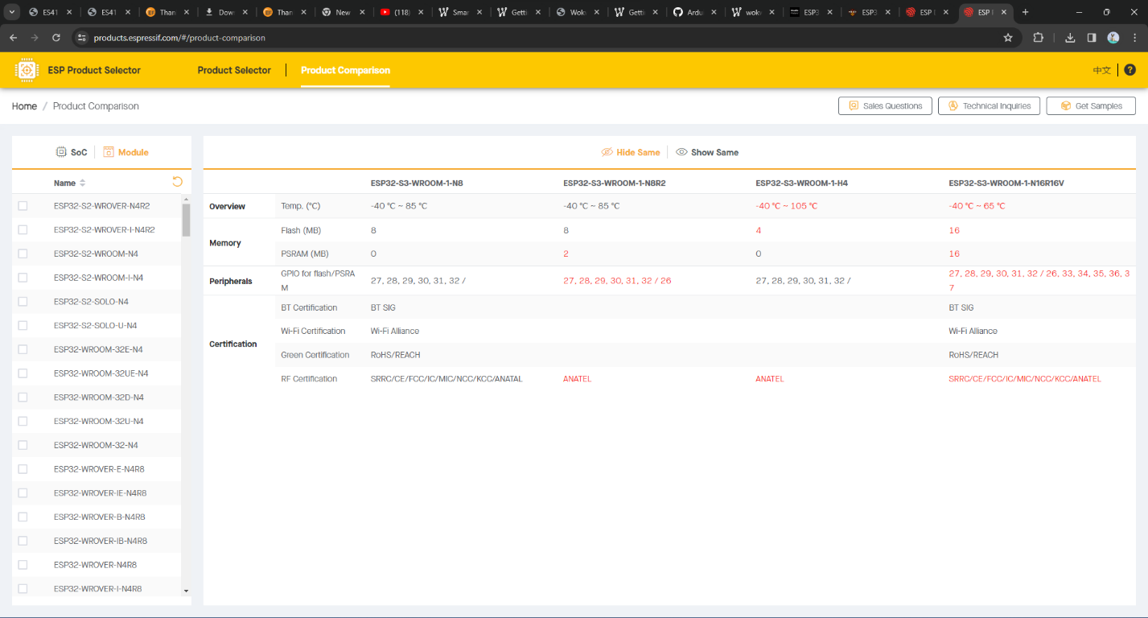

Figure 2 Difference between ESP32-S3-WROOM-1-N8, ESP32-S3-WROOM-1-N8R2, ESP32-S3-WROOM-1-H4 and ESP32-S3-WROOM-1-N16R16V.

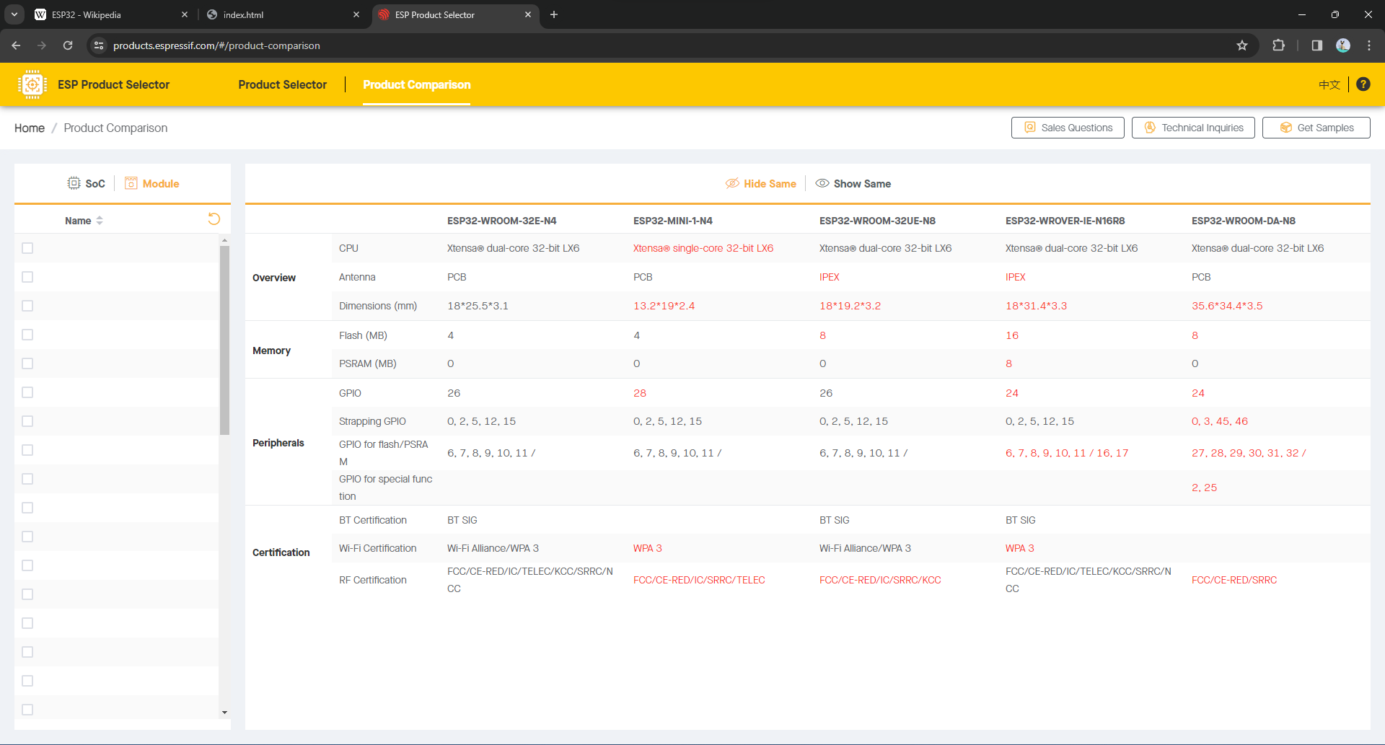

Figure 3 Difference between ESP32-S3-WROOM-32E-N4, ESP32-S3-WROOM-MINI-1-N4, ESP32-S3-WROOM-32UE-N8 and ESP32-S3-WROVER-IE-N16R8, ESP32-WROOM-DA-N8.

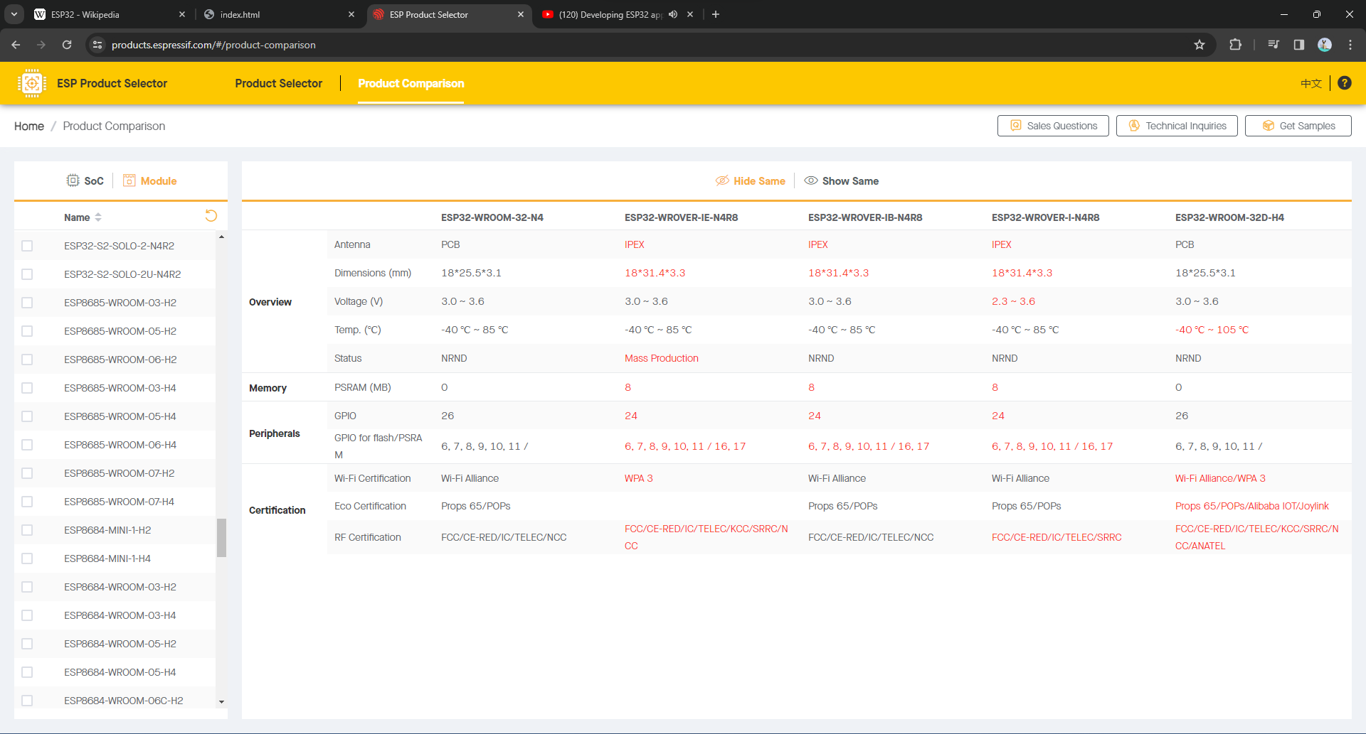

Figure 4 Difference between ESP32-S3-WROOM-32-N4, ESP32-S3-WROVER-IE-N4R8, ESP32-S3-WROVER-IB-N4R8, ESP32-S3-WROVER-I-N4R8 and ESP32-S3-WROOM-32D-N4.

Therefore, for mass-production, ESP32-WROVER-IE-N4R8 seems to fit the required objectives with

* 1. Xtensa@ dual core – 32bit LX6,
  2. Power supply of 3.0 – 3.6 voltage,
  3. Wi-Fi and Bluetooth Low Energy capability,
  4. 4 MB secondary memory,
  5. 8 MB of pseudo random access memory suitable for file transfer service,
  6. Large Esspressif community,
  7. Integrated Development Environment for project development support,
  8. Ultra low power consumption with sleep mode up to 4mA,

## ACCESS AND PURCHASING

The controller ESP32-WROVER-IE-N4R8 can be found on the following link(s):

Taobao: <https://www.taobao.com/list/item/746630559063.htm>

Alibaba: <https://www.alibaba.com/product-detail/Esp32-wrover-e-n4r8-ESP32-WROVER_1601017323766.html?spm=a2700.7735675.0.0.1168pg8npg8nbk&s=p>